COM2005 Assignment 1 - Final Report Group 19

Team members: Joseph Christian Eid, Huzaifa Ahmed and Leto Luana Riebel

**Abstract:** A single paragraph of about 200 words maximum giving a brief overview of the report. You are encouraged to use the following style of structured abstracts, but without headings: 1) Background: Place the question addressed in a broad context and highlight the purpose of the study; 2) Methods: Describe briefly the main methods or treatments applied; 3) Results: Summarize your main findings; and 4) Conclusions: Indicate the main conclusions or interpretations.

1. Introduction and Background (Literature Review) – [guideline 1 page]

With all the great technology humans have developed over the last decades, it is easy to think that we are in control of everything. Often, the influence of natural catastrophes like tsunamis or wild fires is overlooked. An example for this is the Fukushima disaster in 2012. The nuclear power plant was located at the coast without planning for an unlikely but possible tsunami occurrence [1]. Accidents like Fukushima brought the need of accurate simulations that can predict natural causes’ influence well in advance – preferably before power plants or factories are even build.

Soon the advantages of Cellular Automata (‘CA’) were noticed and since then are widely used. They allow for large parameter spaces to be modelled. For example, a 2D-CA with 13 cells has 2169 possible configurations. CA are able to plot form, function, pattern and process of a scenario including time and inter-cellular relationships [2].

Our task was to simulate a wild fire over a terrain made of chaparral, a dense forest, a canyon containing scrubland and a lake. The town close to this area is in need of a reliable simulation of a wild fire spread to account for the possible ignition of the nearby power plant. Furthermore, a waste incinerator is proposed and poses an additional ignition threat. There have been research projects on implementing accurate CAs for wild fire spread in the past that can be used to get a state-of-the-art overview of the topic.

The Department of Mechanical, Chemical and Materials Engineering in the University of Cagliary and the Institute of Biometeorology of the National Research Council in Italy have developed a CA with a to a raster-based approach comparable computational cost but without its limitations. Their study is called ‘An Improved Cellular Automata for Wildfire Spread’. Raster-based approaches struggle to take the distortions that affect a fire’s shape into account. The CA approach also allows more accuracy to show a realistic velocity of the fire’s spread. The research group used correction factors to improve the CA’s performance. Several optimization algorithms were run to improve the impact wind has on a wild fire. They came up with models of fire-spread shapes under different conditions [3].

Another study in the field of wild fire simulation is ‘A Cellular Automaton Model of Wildfire Propagation and Extinction’ written by Keith C. Clarke, James A. Brass and Phillip J. Riggan. The paper was published in 1994 so almost 25 years ago. Still, it gives a good insight into the CA approach and including well explained details on a fire’s physical and chemical processes. To determine the different fuel research parameters is almost impossible without consulting an expert in the topic. The study gave a comprehensible introduction to their approach of taking different terrains into account: ‘Monte Carlo techniques were used to provide fire risk probabilities for areas where fuel loadings and topography are known. The model assumes predetermined or measurable environmental variables such as wind direction and magnitude, relative humidity, fuel moisture content, and air temperature. […] During the fire the reaction itself is strongly influenced by the type and distribution of the fuels. Fastest to burn, and with the greatest intensity, are the fine fuels such as leaf litter, pine needles, and grass. Wood bums comparatively slowly, since the critical ratio seems to be the total surface area exposed rather than the type of fuel material.’ (page 1355 - 1356). The model was tested using data from the Lodi Canyon Fire in 1986. The simulation produced a 82.5% correct fire map calculated on a pixel basis [4].

2. Materials and Methods - [guideline 1-2 pages]

To initiate a CA, we first needed to set the terrain. Each cell gets assign a type of terrain – either lake, chaparral, canyon or dense forest. At a later stage, we also introduced cells representing the town, the waste incinerator and the power plant. The latter three were just for visual purposes and didn’t get assigned ignition likeliness or burning duration parameters, since we are only interested in when the fire reaches each of the locations and not how long or how easily they burn.

Next up we considered how many states we would need for our simulation. The study we introduced in the above literature review section - ‘An Improved Cellular Automata for Wildfire Spread’ [3] – uses four states:

* Unburnable
* Flammable, but currently not ignited
* Flammable and ignited, but the fuel hasn’t been fully consumed yet
* All fuel in the cell has been consumed

An approach similar to the above does make sense for our task as well, since we are working with an unburnable lake and flammable chaparral, canyon and dense forest ground. For simplicity, we chose to make use of only three states: healthy - 0, burning – 1 and burnt - 2.

At the start of the CA we want all cells to be healthy so not burning. Therefore, we set each cell’s state to 0.

Now we need to choose a starting point for the fire. This can be picked in the user interface when running our CA. It allows for multiple fire origin points as well.

Once the map is finalized by the user and the CA is run, each terrain gets assign a likeliness to burn. To make sure the lake doesn’t start burning, we didn’t assign it a likeliness to burn. To make our simulation as realistic as possible, we looked for studies comparing the likeliness to burn of chaparral, canyon and dense forest grounds. Unfortunately, the terrain’s likeliness to burn depends on a lot of external factors e.g. temperature, humidity, the flora’s density and previous fires. We therefore couldn’t, considering how little time and background knowledge we had, include real world parameters.

We did however, find several sources making a rough comparison of likeliness to burn between different types of leaves, grass and wood [4], [5]. We then did some research on what kind of plants the different terrains are made of. Chaparral and canyon lands are usually found in North-West America so we focused on studies from that area, since it is most similar to the one we were given.

Chaparral grounds consist mostly of grass and some bushes or pine trees [6]. Therefore, it has a high likeliness to catch on fire.

Canyons containing scrubland grow, especially in the USA, in quite dry and hot climate. That results in a vegetation of dry grassland with rare occurrence of small pine or oak trees [7]. According to this, the canyon’s likeliness to burn is even higher than the chaparral’s.

Dense forests are mainly made of wood meaning that they don’t catch on fire easily.

We calculated a terrain’s likeliness to burn by picking a random number within a set range. The smaller the range, the more likely the cell is to catch on fire. Basically, every cell in a terrain is different although it is part of the same terrain. The randomness simulates the varying density, humidity or occurrence of trees and makes the simulation look more realistic. After running several test simulations with varying ranges for each terrain, we ended up choosing a range of 3 for the canyon, a range of 8 for the chaparral and a range of 15 for the dense forest. Include reference to code in appendix.

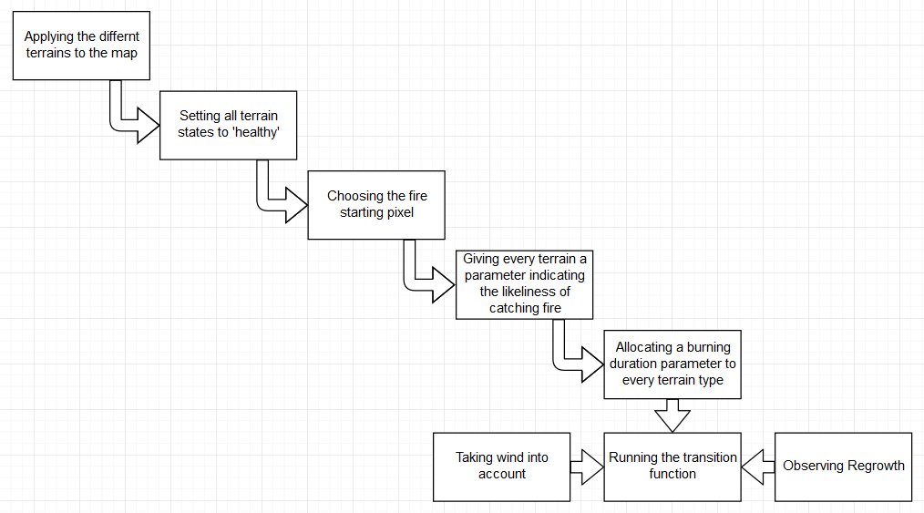

A short summary (IN YOUR OWN WORDS) of how you have applied the CA approach to model a forest fire. This should assume that the reader is a non-expert in modelling or Computer Science in general. You should explain in English (as opposed to simply using code), how you have extended the model you have been given in order to investigate the features mentioned. You can also use simple flow or state transition diagrams to support your description. You can also refer to relevant python code in an appendix.

It is expected that in extending/developing your model you will have to make some assumptions about how to implement particular behaviours, and also in the parameters (values) you choose to use e.g. to represent different fuel resources/burning or regeneration times. You are not expected to become experts in this area but you should at least state, and if possible, justify any assumptions you make.

3. Results [guideline 2-3 pages]

In this section you should describe what simulations you carried out under which conditions (e.g. parameter values, wind direction,…) and how long (in time steps) each simulation was run for. You should use fully labelled diagrams (e.g. screenshots or where appropriate, line graphs) to display your results and you should also describe your results in text.

You should aim to provide a concise and precise description of your results, their interpretation as well as the conclusions that can be drawn. This section may be divided by subheadings and you will also use figures and possibly tables. Guidelines for formatting these are as follows (replace text below with your own!):.

3.1. Subsection

3.1.1. Sub subsection

3.2. Figures, Tables and Schemes

All figures and tables should be cited in the main text as Figure 1, Table 1, etc.

|  |  |
| --- | --- |
| C:\Users\martin\Downloads\testFigure.tif  (**a**) | C:\Users\martin\Downloads\testFigure.tif  (**b**) |

**Figure 1.** This is a figure; Schemes follow the same formatting. If there are multiple panels, they should be listed as: (**a**) Description of what is contained in the first panel; (**b**) Description of what is contained in the second panel. Figures should be placed in the main text near to the first time they are cited. A caption on a single line should be centered.

**Table 1.** This is a table. Tables should be placed in the main text near to the first time they are cited.

|  |  |  |
| --- | --- | --- |
| **Title 1** | **Title 2** | **Title 3** |
| entry 1 | data | data |
| entry 2 | data | data 1 |

1 Tables may have a footer.

4. Discussion [Guideline 1-2 pages]

- compare to four state in [3]

- improve using Monte Carlo [4]

Summarise your most important findings, clearly addressing the questions that your client asked you to explore. How reliable do you think your results are? If you change some of the assumptions and values that you have used in your model, do your conclusions remain the same? How could your model be made more realistic (assuming your client has the funds for you to extend your study!)?

You can also consider how your model and findings may relate to those from the literature that your mentioned in section 1.

5. Conclusions [Max 0.5 pages]

Briefly state the main conclusions resulting from your study.

**Supplementary Materials:** You may wish to include links to additional media such as videos showing simulations.

**THE LENGTH OF YOUR REPORT TO THIS POINT SHOULD NOT EXCEED 7 PAGES (around 3500 words)**

Appendix A [Nothing below here will count towards your word/page limit]

The appendix is an optional section that can contain details and data supplemental to the main text. For example, figures of repeats of simulations for which representative data is shown in the main text can be added here if brief, or as Supplementary data. Key sections of code or pseudocode can also be included here.

All appendix sections must be cited in the main text. In the appendixes, Figures, Tables, etc. should be labeled starting with ‘A’, e.g., Figure A1, Figure A2, etc.

References

References must EITHER be numbered in order of appearance in the text (including citations in tables and legends) and listed individually at the end of the manuscript in order of appearance (example shown below). In the text, reference numbers should be placed in square brackets [ ], and placed before the punctuation; for example [1], [1–3] or [1,3].. ALTERNATIVELY, references can be cited in the text as [*Author, year]* and appear in the bibliography in alphabetical order. Please consistently stick to one system. You may wish to prepare references with a bibliography software package, such as EndNote, ReferenceManager or Mendeley to avoid typing mistakes and duplicated references.

1. Author 1, A.B.; Author 2, C.D. Title of the article. *Abbreviated Journal Name* **Year**, *Volume*, page range, DOI.
2. Author 1, A.; Author 2, B. Title of the chapter. In *Book Title*, 2nd ed.; Editor 1, A., Editor 2, B., Eds.; Publisher: Publisher Location, Country, 2007; Volume 3, pp. 154–196, ISBN.
3. Author 1, A.; Author 2, B. *Book Title*, 3rd ed.; Publisher: Publisher Location, Country, 2008; pp. 154–196, ISBN.
4. Title of Site. Available online: URL (accessed on Day Month Year).

**Useful Links**

- <https://www.nationalgeographic.com/environment/natural-disasters/wildfires/> 08/03/2018

- <http://www.havasiwf.org/understanding-wildfire-in-the-chaparral-of-southern-california/>

- [http:/www.californiachaparral.com/chaparralmyths.html](http://www.californiachaparral.com/chaparralmyths.html) damage depends on type and intensity of fire

<https://www.ncbi.nlm.nih.gov/pmc/articles/PMC4379084/>

<http://www.bbc.co.uk/schools/gcsebitesize/science/ocr_gateway/carbon_chemistry/carbon_fuelsrev1.shtml>

<https://www.environment.gov.au/resource/proposed-standards-fuel-parameters-petrol-and-diesel>

- <http://www.californiachaparral.com/fire/firenature.html> chaparral regrowth 07/03/2018

- <https://www.newscientist.com/article/dn14112-how-long-does-it-take-a-rainforest-to-regenerate/> forest regrowth

[1] <http://www.world-nuclear.org/information-library/safety-and-security/safety-of-plants/fukushima-accident.aspx>, last viewed on 12/03/2018 14:10

[2] <http://geography.name/the-advantages-of-cellular-automata-modeling-in-the-geographic-sciences/>, last viewed on 12/03/2018 14:25

[3] <http://www.academia.edu/23687170/An_Improved_Cellular_Automata_for_Wildfire_Spread>, last viewed on 12/03/2018 14:40

[4] <https://www.fs.fed.us/psw/publications/riggan/psw_1994_riggan003.pdf>, last viewed on 12/03/2018 15:09

[5] <https://www.tandfonline.com/doi/pdf/10.1080/00102200490474278>, last viewed on 13/03/2018 13:22

[6] <http://www.blueplanetbiomes.org/chaparral_plant_page.htm>, last viewed on 13/03/2018 13:24

[7] <http://animals.sandiegozoo.org/habitats/scrubland>, last viewed on 13/03/2018 13:41

[8]